**Style Guide**

**Rafael & Jaime & Miguel project**

Introduction:

This is “Chirp”: Style guide.

Introduction:

Welcome to Chirp, where brevity meets connectivity! This Style Guide is designed to ensure a consistent and engaging experience for our users across the platform. From typography to tone, let's embark on a journey to define the essence of SocialSphere.

Logo and Visual Identity:

The Chirp logo represents the convergence of ideas and conversations. Maintain clear space around the logo to enhance visibility. The primary colour palette comprises vibrant blues and greens, reflecting a dynamic and friendly atmosphere. Utilize the secondary palette for accents and highlights, ensuring a harmonious visual experience.

Typography:

Our typefaces are carefully chosen to convey a sense of modernity and readability. Use " " for headers and " " for body text. Maintain a consistent font size to enhance legibility on various devices.

Iconography:

Icons play a crucial role in communication. Chirp employs a set of minimalist icons that convey actions intuitively. Consistency in iconography enhances user understanding and engagement.

User Interface (UI):

Clarity and simplicity define our UI. Employ a clean and intuitive design that allows users to navigate seamlessly. Utilise cards for displaying content, ensuring a uniform structure across the platform.

Colour Usage:

Colour communicates emotions and moods. Use the primary color palette for buttons and calls-to-action. Employ contrasting colors for alerts and notifications, drawing attention to important updates.

Voice and Tone:

Chirp embodies a conversational and inclusive tone. Encourage users to express themselves authentically while maintaining respect for diverse perspectives. Keep messages concise and engaging, aligning with the platform's essence.

Content Guidelines:

Foster a positive environment by discouraging offensive content. Provide clear guidelines on acceptable content, promoting healthy discussions and interactions. Encourage users to share diverse perspectives while discouraging hate speech and harassment.

Hashtags and Trends:

Hashtags are the heartbeat of SocialSphere. Encourage users to create and follow trends that align with the platform's values. Implementing a trending algorithm ensures users discover and participate in discussions that matter to them.

Accessibility:

Make Chirp accessible to all. Prioritise inclusive design principles, ensuring features are usable for individuals with varying abilities. Provide alternative text for images and consider colour contrasts for readability.

Security and Privacy:

User trust is paramount. Outline clear policies regarding data privacy and security measures. Regularly update users on security practices and provide tools to manage their privacy settings effectively.

This Style Guide serves as a foundation for maintaining a cohesive and user-friendly experience on Chirp. As the platform evolves, continue refining and expanding these guidelines to uphold the essence of our dynamic community.

Color Palette

***Main Color Palette***

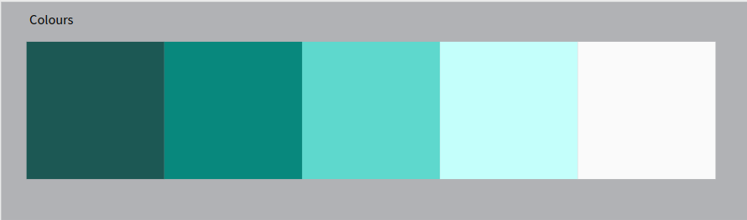

Since the website is going to be a social network, it is required that it be as

as simple and readable as possible, and that is why the main color palette is this range of colors. Since this will basically be used to interact primarily on the web, menus and texts.

***Typography***

***Image sizing***

***Icons***

***Mockups***